**Activity 5:** Jokes App with Data Source

Ryan Scott

Grand Canyon University  
Mobile Game Development

Prof. Shad Sluiter

**Part 1 Screenshots:**

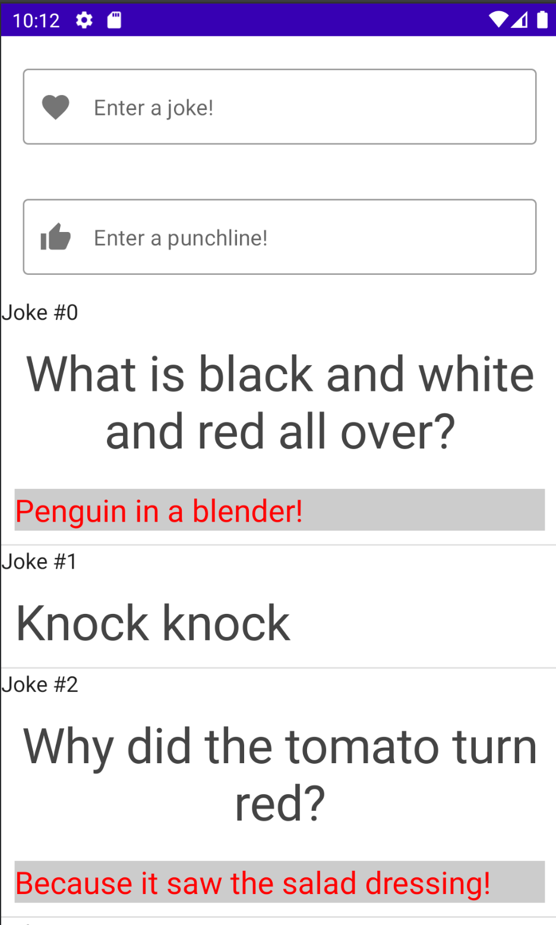

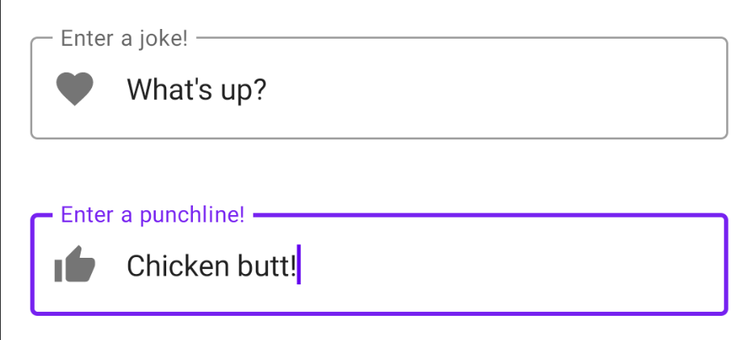

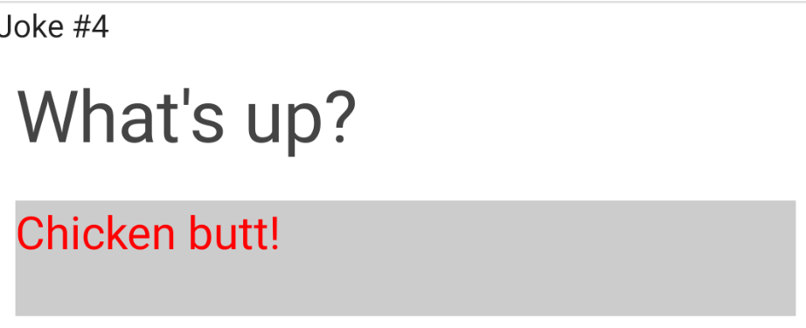

**Part 2 Screeshots:**



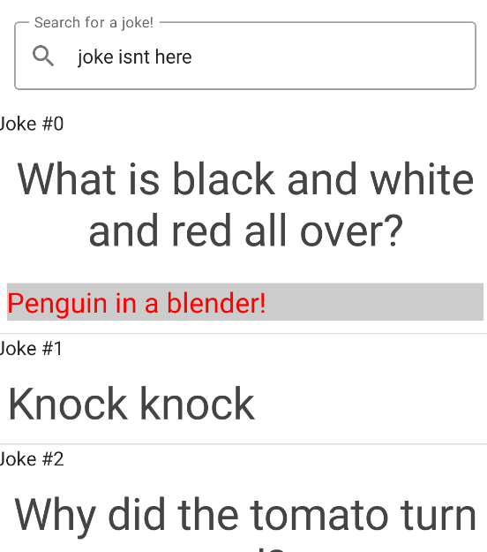

# What I learned

In this Kotlin lesson, I learned about creating a data repository and using observable data to update UI components automatically when the data changes. I also learned how to use a viewModel data structure to manage and store UI-related data, which survives configuration changes such as screen rotations. Additionally, I learned how to add a data entry form to create new jokes, which allows users to input data and add it to the repository. Overall, this lesson provided a solid foundation for building more complex apps that involve working with data in Kotlin in Android Studio.